CHAPTER 6

IMAGE SEGMENTATION

6.1 Thresholding Techniques
6.2 Clustering for Segmentation: Kmeans and ISODATA
6.3 Region-based Segmentation, Watershed Algorithm

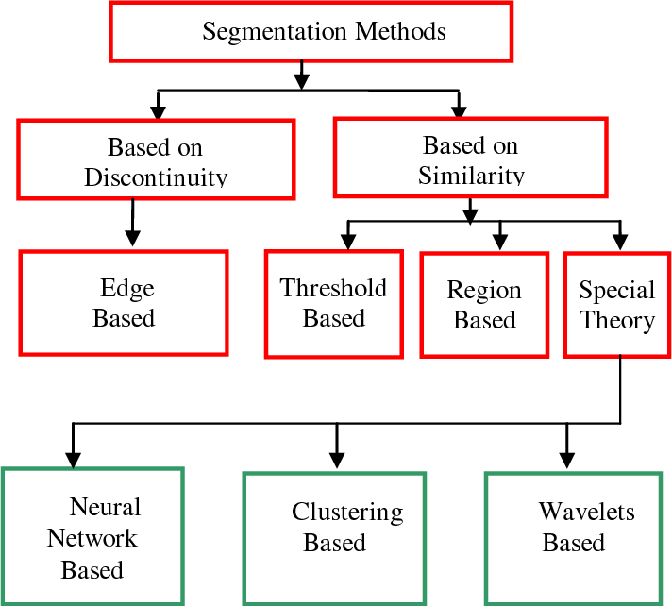

6.1 Thresholding Techniques
https://www.scaler.com/topics/thresholding-in-image-processing/
What is Image Thresholding?
- Thresholding in image processing is the task of selecting a threshold value to separate the pixels of an image into two classes: foreground and background.
- In a grayscale image, each pixel is represented by an intensity value that ranges from 0 (black) to 255 (white).
- Pixels with intensity values above the threshold are assigned one value, white, while those below the threshold are assigned another value, black.
- In simple terms, thresholding involves assigning a value of 0 or 1 to each pixel in the image, based on whether its intensity is above or below the selected threshold value.
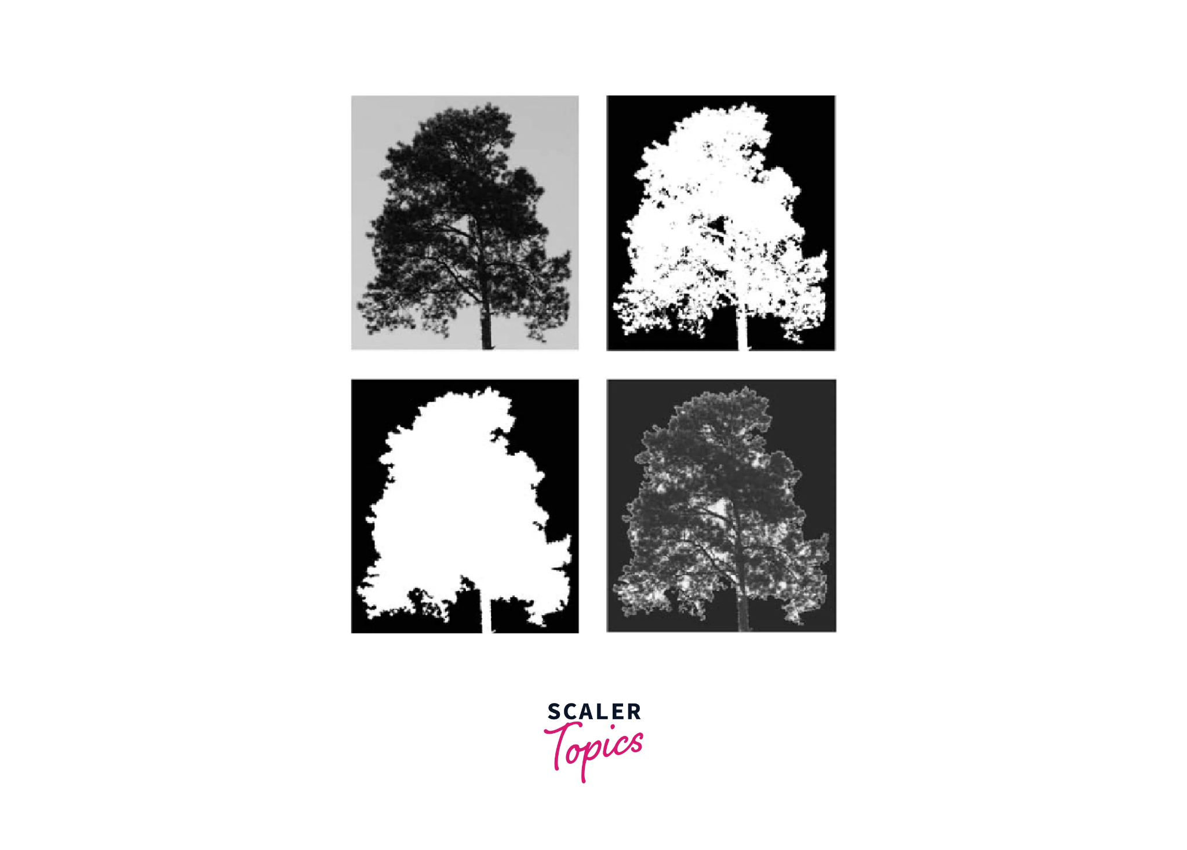

6.1.1. Global Thresholding (e.g., Otsu's Method)
- Definition: Applies a single threshold value globally to the entire image.
- Features:
  - Suitable for images with uniform lighting conditions.
  - Threshold value can be selected manually or automatically
6.1.1.1 Basic Global Thresholding(Threshold Selected Manually)
  - An example of global thresholding is when a single, fixed threshold is applied to an entire image. Each pixel in the image is replaced
    - with a black pixel if its intensity is less than the threshold,
    - with a white pixel if its intensity is greater than the threshold.
  - Consider a grayscale image with pixel values ranging from 0 to 255.
  - Set a global threshold value of 150.
  - For each pixel, if the value is less than 150, set it to 0 (black). If the value is 150 or greater, set it to 255 (white).
  - Global thresholding can be inaccurate in certain situations, such as when images are captured under uneven lighting conditions.
6.1.1.2 Otsu’s Method:(Automatically determines the optimal threshold)
  - Automatically determines the optimal threshold by minimizing intra-class variance.
  - Best for images with bimodal intensity distributions.
- Steps for Otsu's Method:
- Compute the Histogram
  - Generate the histogram of the grayscale image to analyze the intensity distribution.
- Compute a Global Threshold
  - Randomly choose a threshold value
  - Divide the histogram into two classes at every possible threshold.
  - Compute intra-class variance and find the threshold that minimizes it.
- Apply the Threshold
  - For each pixel
    - 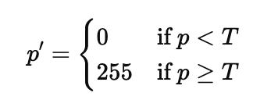
- Generate Binary Image
    - Output a binary image with two intensity levels: 0 (black) and 255 (white).

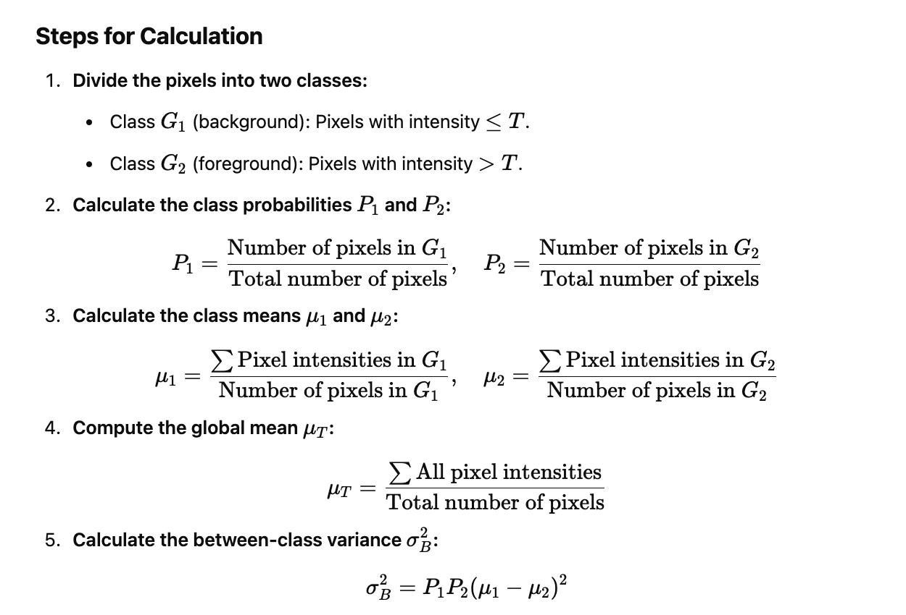

Here all 0 to 255 values will be taken as a Threshold iteratively ,and find variance.Threshold will be selected whose Variance is Highest.

Solved Numerical PB::In a grayscale image, pixel intensities in two regions are: [50, 55, 60] and [100, 105, 110]. Compute the between-class variance using Otsu's method for a threshold of 80.
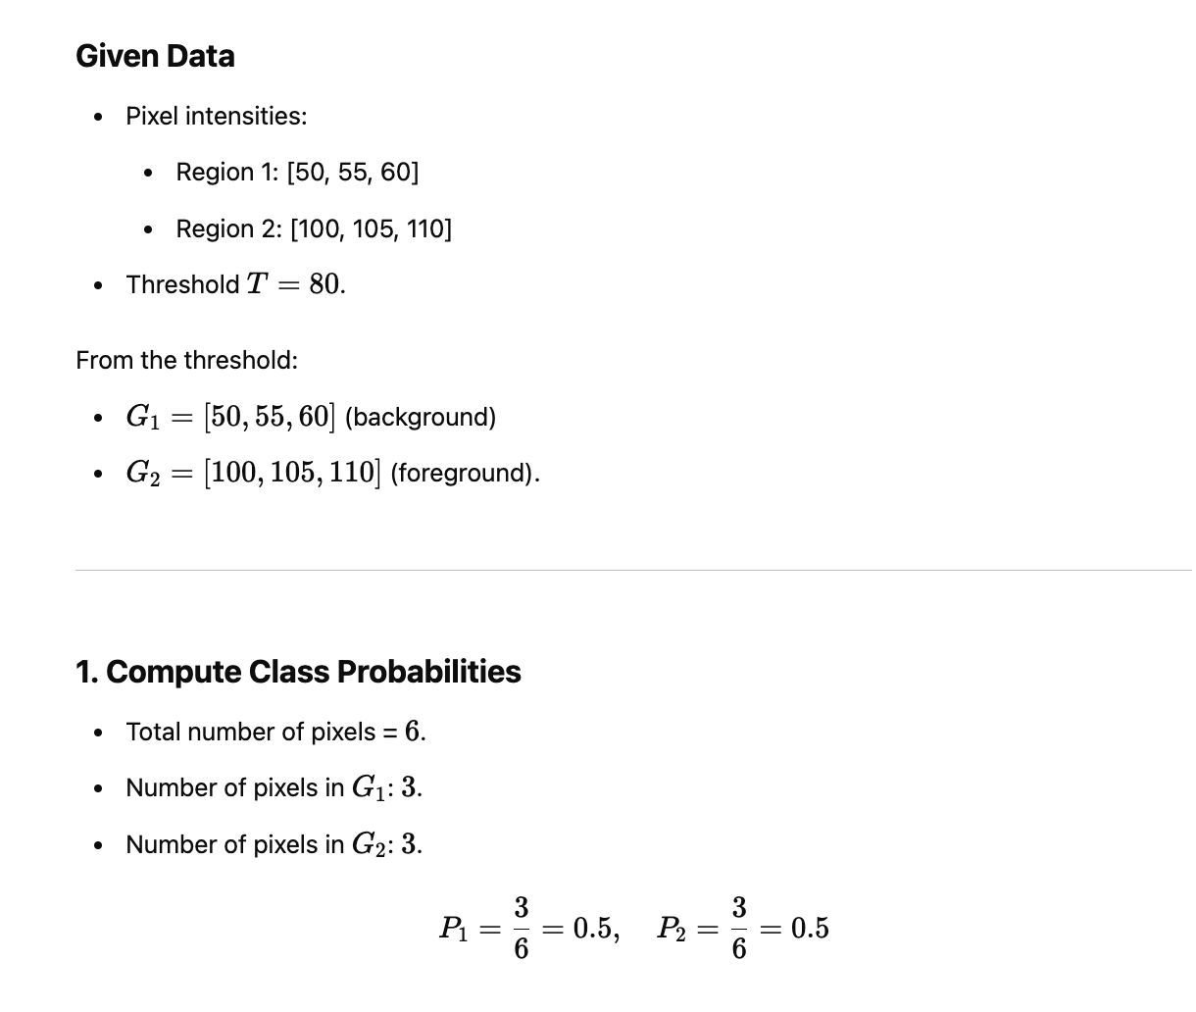
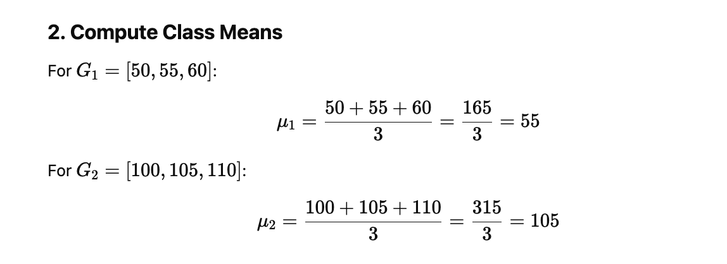
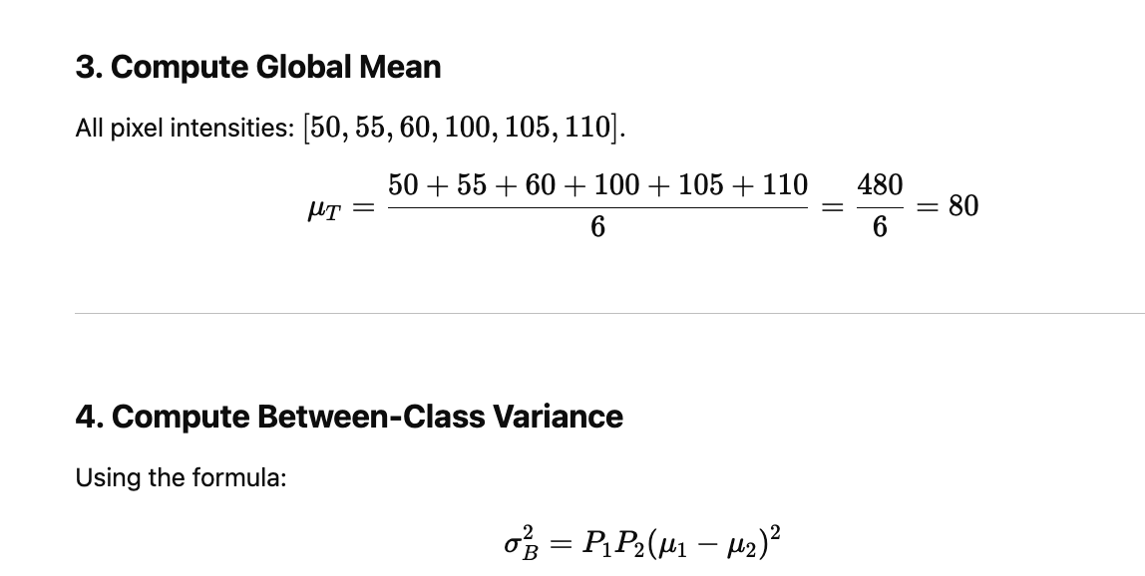
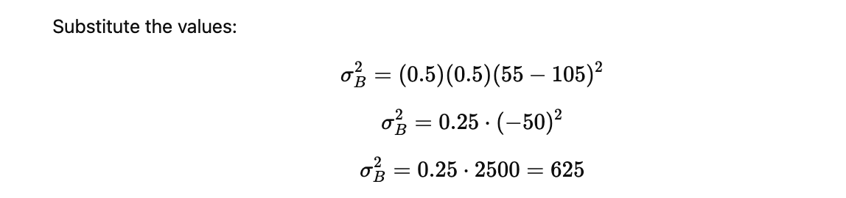
Solved Numerical PB:::An image contains regions with pixel intensities: [10, 10, 12, 200, 205, 210]. Use Otsu’s method to calculate the inter-class variance for a threshold at 100.
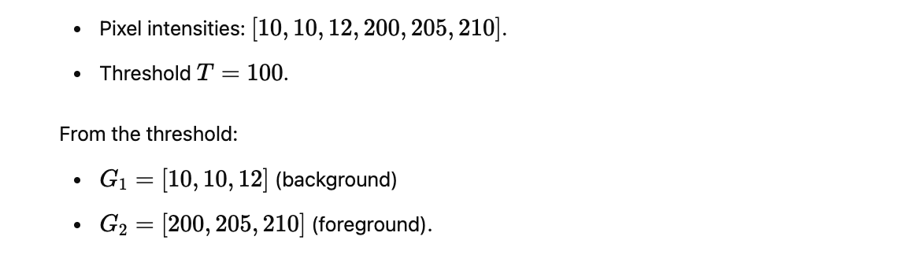
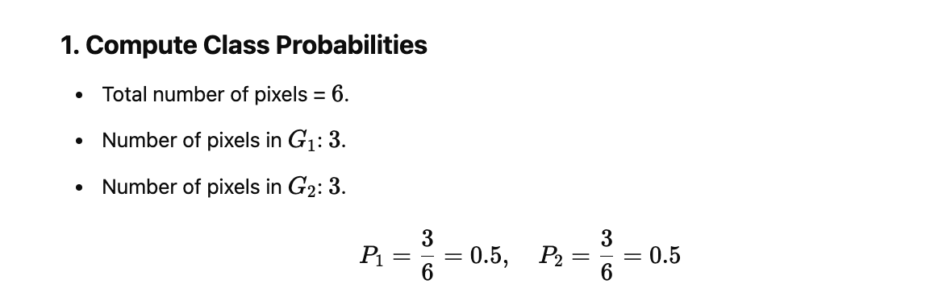
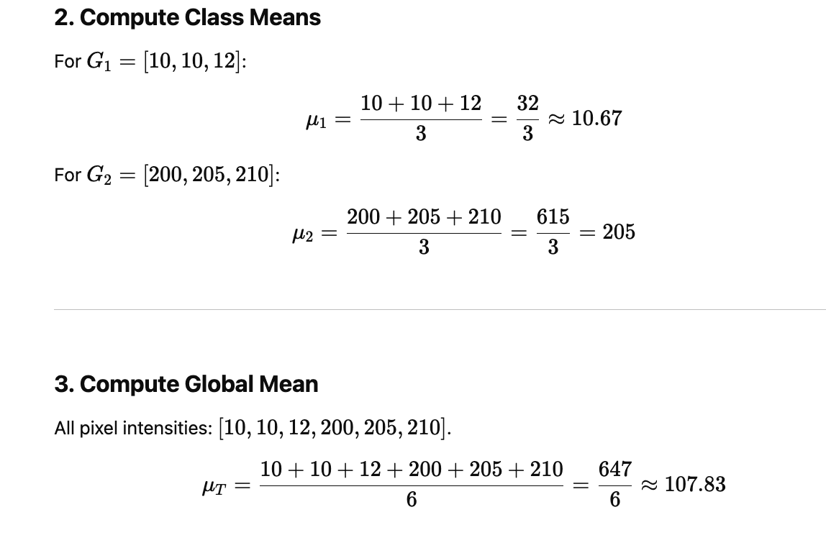
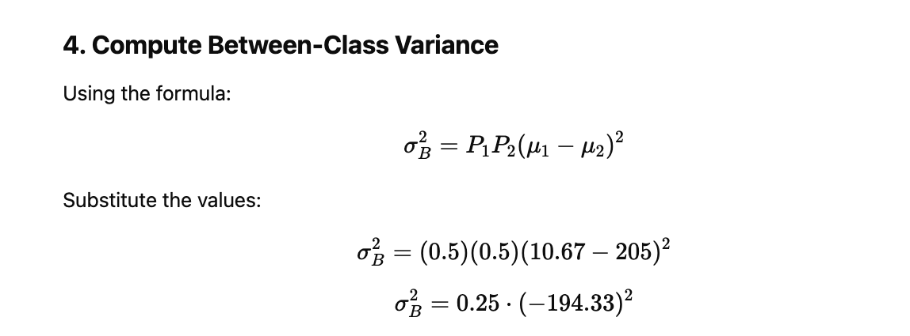
Here Variance is 9441.03
IMP:If in question two different thresholds are given,all values need to be calculated for both thresholds.

# Read the image in grayscale
img = cv2.imread('image.jpg', 0)
#Apply Simple thresholding
rets, thresholds = cv2.threshold(img, 127, 255, cv2.THRESH_BINARY)
# Apply Otsu's Thresholding
ret, threshold = cv2.threshold(img, 0, 255, cv2.THRESH_BINARY + cv2.THRESH_OTSU)

# Display the result
cv2.imshow(‘Simple Threshold', thresholds)
cv2.imshow('Otsu Threshold', threshold)

# Apply segmentation
contours, hierarchy = cv2.findContours( threshold, cv2.RETR_TREE, cv2.CHAIN_APPROX_SIMPLE)

# Draw contours on the image
segmented_image = cv2.drawContours(img, contours, -1, (0, 255, 0), 2)

# Display result
cv2.imshow("Segmented Image", segmented_image)
cv2.waitKey(0)
cv2.destroyAllWindows()

- Advantages:
  - No need to manually select the threshold.
  - Works well for bimodal distributions.
- Disadvantages:
  - Fails in non-uniform lighting conditions.

6.1.2. Adaptive Thresholding (Mean and Gaussian)
- Definition: Calculates the threshold for each pixel based on its local neighborhood.
- Features:
  - Suitable for images with varying lighting conditions.
  - Thresholding adapts to local image intensity variations.
- Methods:
  - Mean Adaptive Thresholding: Threshold is the mean intensity of the local neighborhood.
  - Gaussian Adaptive Thresholding: Threshold is the weighted sum (Gaussian kernel) of local intensities.
- Steps:In adaptive thresholding, the threshold is computed locally for each pixel using its surrounding neighborhood.
- Choose the Neighborhood Size
  - Define the size of the local region (e.g., a n×n window) to compute the threshold for each pixel.
- Compute Local Threshold
  - Mean Adaptive: Use the average intensity of the neighborhood as the threshold.
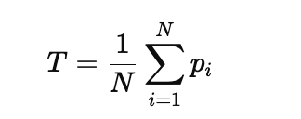
  - Gaussian Adaptive: Use a weighted average (Gaussian filter) to assign more weight to nearby pixels.
- Apply the Local Threshold
  - For each pixel
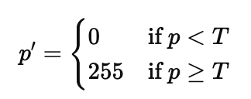
- Generate Binary Image
  - Produce the output binary image.
import cv2

# Read the image in grayscale
img = cv2.imread('image.jpg', 0)

# Apply Mean Adaptive Thresholding
threshold_mean = cv2.adaptiveThreshold(img, 255, cv2.ADAPTIVE_THRESH_MEAN_C, cv2.THRESH_BINARY, 11, 2)

# Apply Gaussian Adaptive Thresholding
threshold_gaussian = cv2.adaptiveThreshold(img, 255, cv2.ADAPTIVE_THRESH_GAUSSIAN_C, cv2.THRESH_BINARY, 11, 2)

# Display the results
cv2.imshow('Mean Adaptive Threshold', threshold_mean)
cv2.imshow('Gaussian Adaptive Threshold', threshold_gaussian)
cv2.waitKey(0)
cv2.destroyAllWindows()
JUST FOR UNDERSTANDING
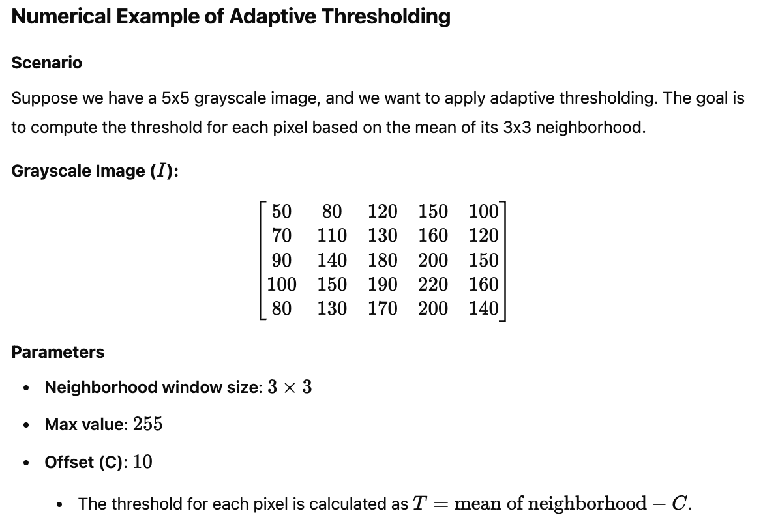
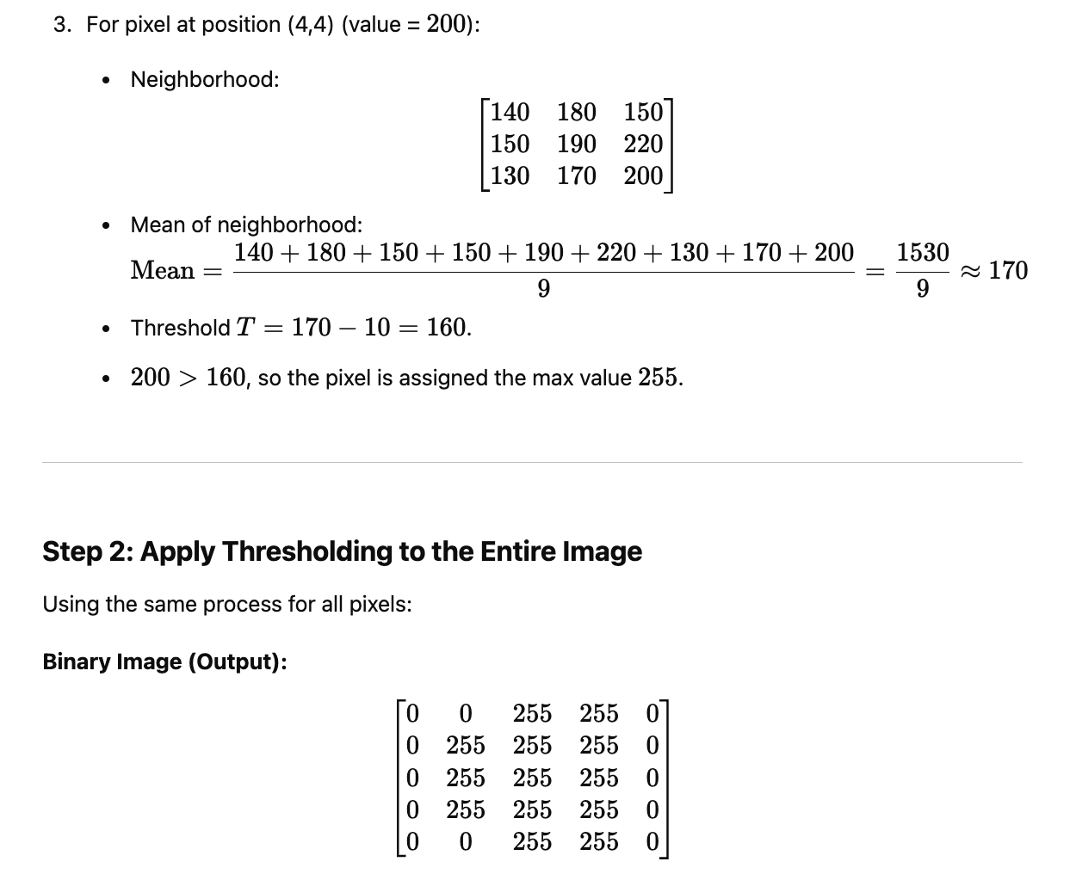
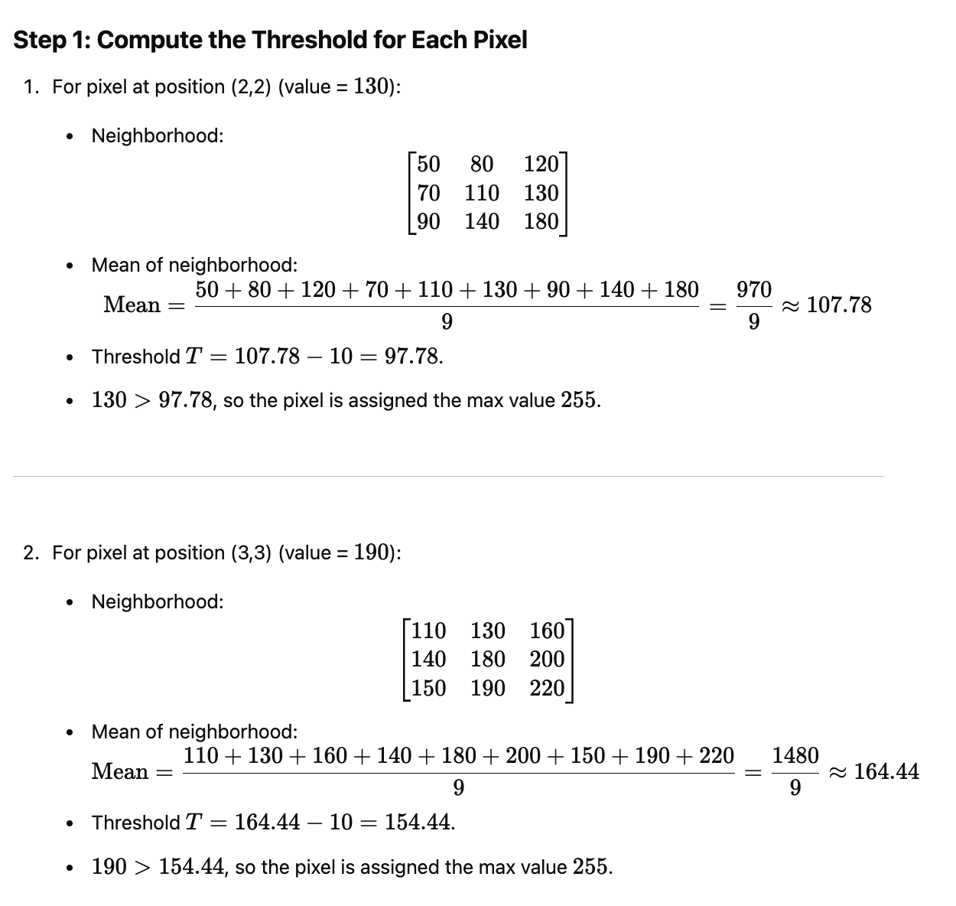
- Advantages:
  - Handles non-uniform lighting well.
  - Enhances local features.
- Disadvantages:
  - Computationally more expensive than global thresholding.

Comparison of Techniques
Technique | Best For | Limitations
Global Thresholding | Uniform lighting conditions | Ineffective with uneven lighting
Adaptive Thresholding | Non-uniform lighting conditions | Computationally expensive

https://blog.roboflow.com/image-thresholding/

6.2 Clustering for Segmentation

6.2.1. K-means Clustering in Image Processing

Concept:
K-means clustering is a partitioning method where the goal is to divide an image into a pre-defined number of clusters (K) based on the pixel values or image features (e.g., color intensity, texture, etc.). It aims to minimize the variance within each cluster.

Steps:
- Initialization: Choose K initial cluster centroids randomly (either from the pixels or randomly in the feature space).
- Assignment: Assign each pixel (or feature) in the image to the nearest centroid.
- Update: Compute the new centroids by taking the mean of all pixels assigned to each centroid.
- Repeat: Continue the assignment and update steps until the centroids no longer change significantly (convergence).

Application in Image Processing:
- Image Segmentation: In an image, each pixel has color and intensity values. K-means can be applied to segment the image into regions of similar colors or intensities by clustering the pixels into groups. Each cluster represents a different region of the image.
- Color Quantization: K-means can reduce the number of colors in an image by clustering the colors in the image and assigning each pixel to the nearest color cluster. This is useful in image compression and artistic rendering.

Solved PB:: Here for K=2 and centroid 20 and 120 is assumed.
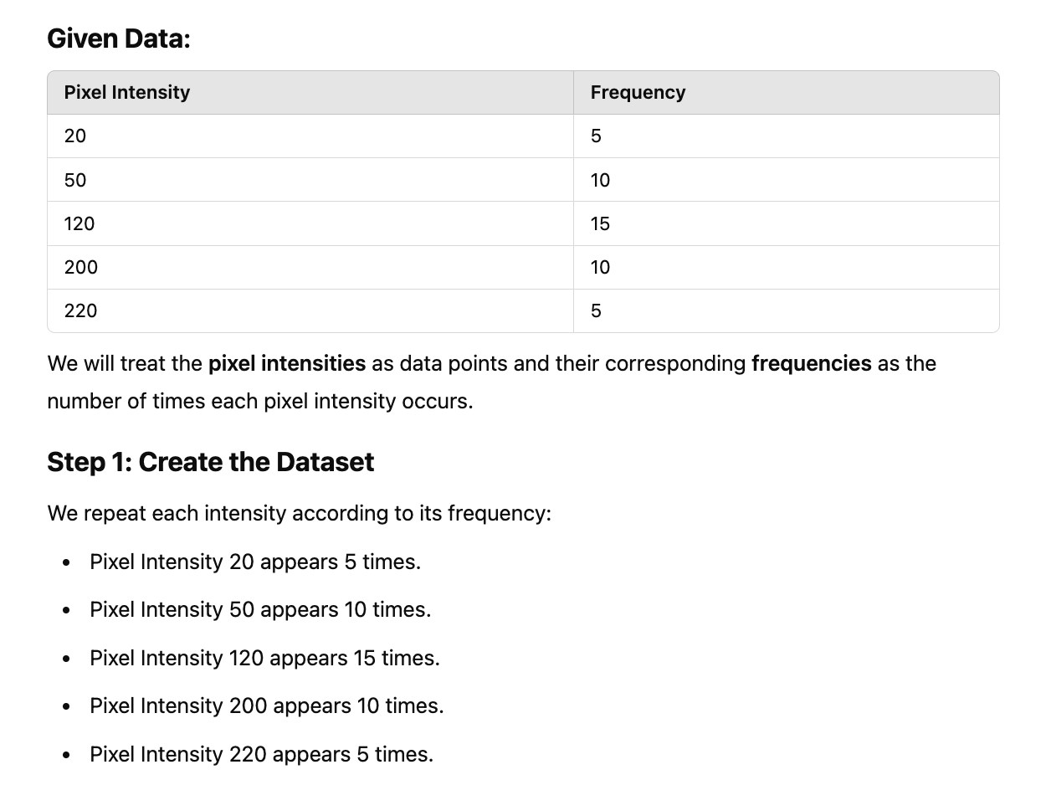
Data=[20,20,20,20,20,50,50,50,50,50,50,50,50,50,120,120,120,120,120,120,120,120,120,120,120,120,120,120,120,200,200,200,200,200,200,200,200,200,220,220,220,220,220]
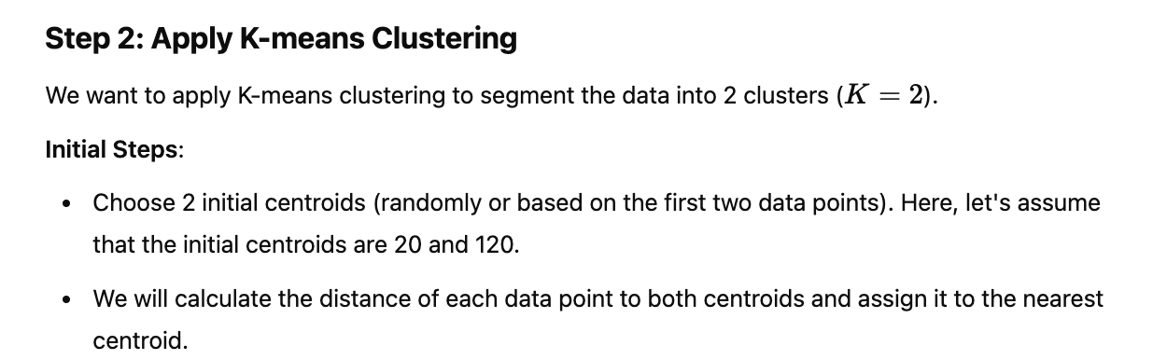
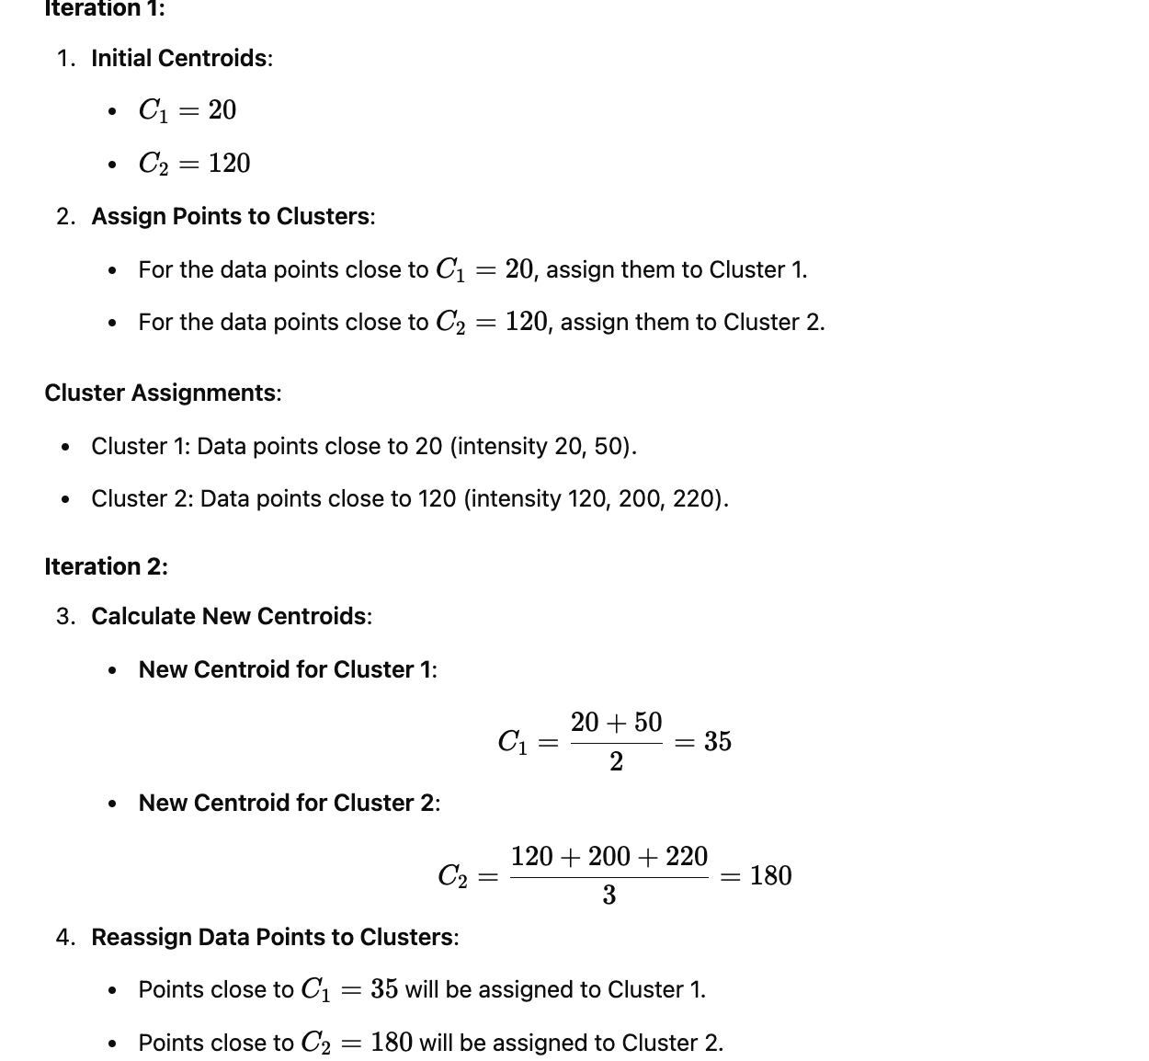

To choose clusters:
C1=20 | C2=120 | Clusters:min(C1,C2)
|20-20| = 0 | |120-20| = 100 | C1 | C1=[20,50]
|20-50| = 30 | |120-50| = 70 | C1 | C1=[20,50]
|20-120| = 100 | |120-120| = 0 | C2 | C2=[120,200,220]
|20-200|=180 | |120-200|=80 | C2 | C2=[120,200,220]
|20-220|=200 | |120-220|=100 | C2 | C2=[120,200,220]

To choose clusters:
C1=35 | C2=180 | Clusters:min(C1,C2)
|35-20| = 15 | |180-20| = 160 | C1 | C1=[20,50]
|35-50| = 15 | |180-50| = 130 | C1 | C1=[20,50]
|35-120| = 85 | |180-120| = 60 | C2 | C2=[120,200,220]
|35-200|=165 | |180-200|=20 | C2 | C2=[120,200,220]
|35-220|=185 | |180-220|=40 | C2 | C2=[120,200,220]

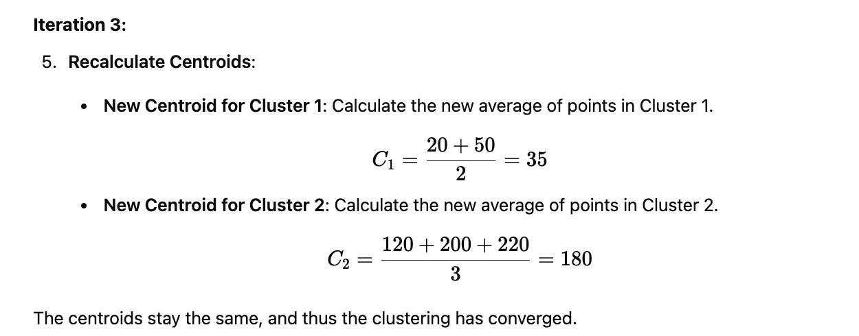

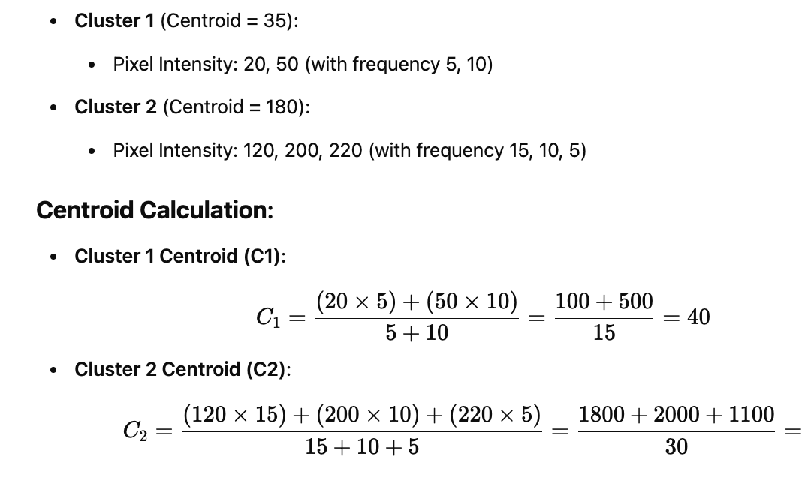
C1= 40 and C2= 163.33

import cv2
import numpy as np
import matplotlib.pyplot as plt

# Load an image (can replace with any image from your dataset)
image = cv2.imread('image.jpg') # Replace with path to your image
image = cv2.cvtColor(image, cv2.COLOR_BGR2RGB) # Convert to RGB

# Reshape the image to a 2D array of pixels
pixels = image.reshape((-1, 3))

# Convert to float32 for kmeans
pixels = np.float32(pixels)

# Define criteria and apply kmeans()
criteria = (cv2.TERM_CRITERIA_EPS + cv2.TERM_CRITERIA_MAX_ITER, 100, 0.2)
k = 3 # Number of clusters (segments)
_, labels, centers = cv2.kmeans(pixels, k, None, criteria, 10, cv2.KMEANS_RANDOM_CENTERS)

# Convert centers back to 8 bit values
centers = np.uint8(centers)

# Map each pixel to the center of the cluster
segmented_image = centers[labels.flatten()]
segmented_image = segmented_image.reshape(image.shape)

# Display the original and segmented images
plt.figure(figsize=(10,5))
plt.subplot(1, 2, 1)
plt.imshow(image)
plt.title("Original Image")
plt.subplot(1, 2, 2)
plt.imshow(segmented_image)
plt.title("Segmented Image (K-means)")
plt.show()

6.2.2. ISODATA Clustering in Image Processing

Concept:
ISODATA (Iterative Self-Organizing Data Analysis Technique) clustering is an extension of K-means that adapts to the data by splitting and merging clusters dynamically. Unlike K-means, which requires a predefined number of clusters, ISODATA can change the number of clusters during the process by splitting clusters that are too varied (high variance) or merging clusters that are too close (low centroid distance).

Steps:
- Initialization: Choose initial clusters (can be random or based on some heuristic).
- Assignment: Assign each pixel (or feature) to the nearest centroid.
- Update: Calculate the new centroids by taking the mean of the pixels in each cluster.
- Splitting: If the variance within a cluster exceeds a predefined threshold, split it into two new clusters.

Variance > Splitting threshold —-----------SPLIT
Variance <=Splitting threshold —-----------NO SPLIT

- Merging: If the distance between two centroids is smaller than a predefined threshold, merge those two clusters.

Distance >= Merge threshold —-----------NO MERGE
Distance < Merge threshold —-----------MERGE

- Repeat: Continue the steps until the clusters stabilize.

PB: Explain how ISODATA clustering would process the following data points with initial clusters: Cluster 1: (2,10),(3,8),(1,9) Cluster 2: (10,2),(12,4),(9,3) Given: Splitting variance threshold = 5, merging distance threshold = 3.
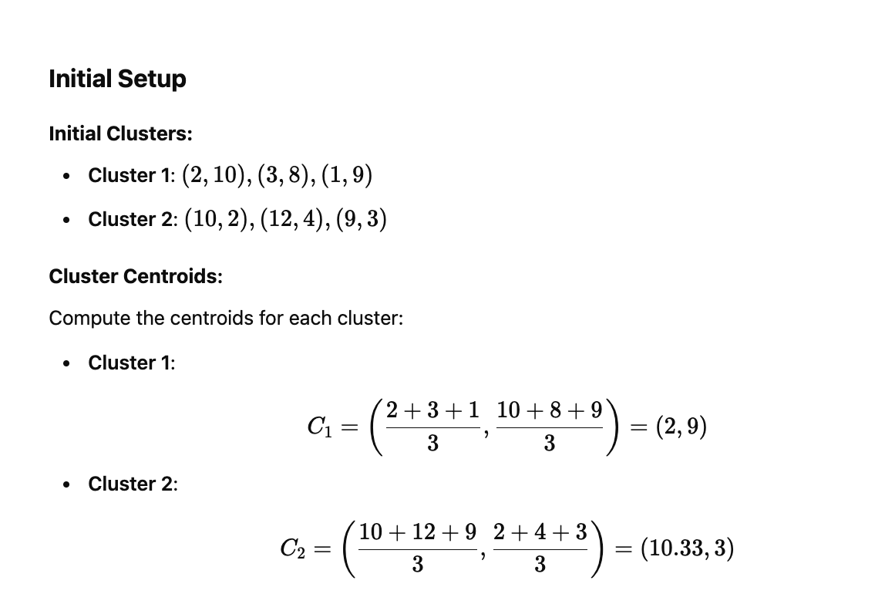
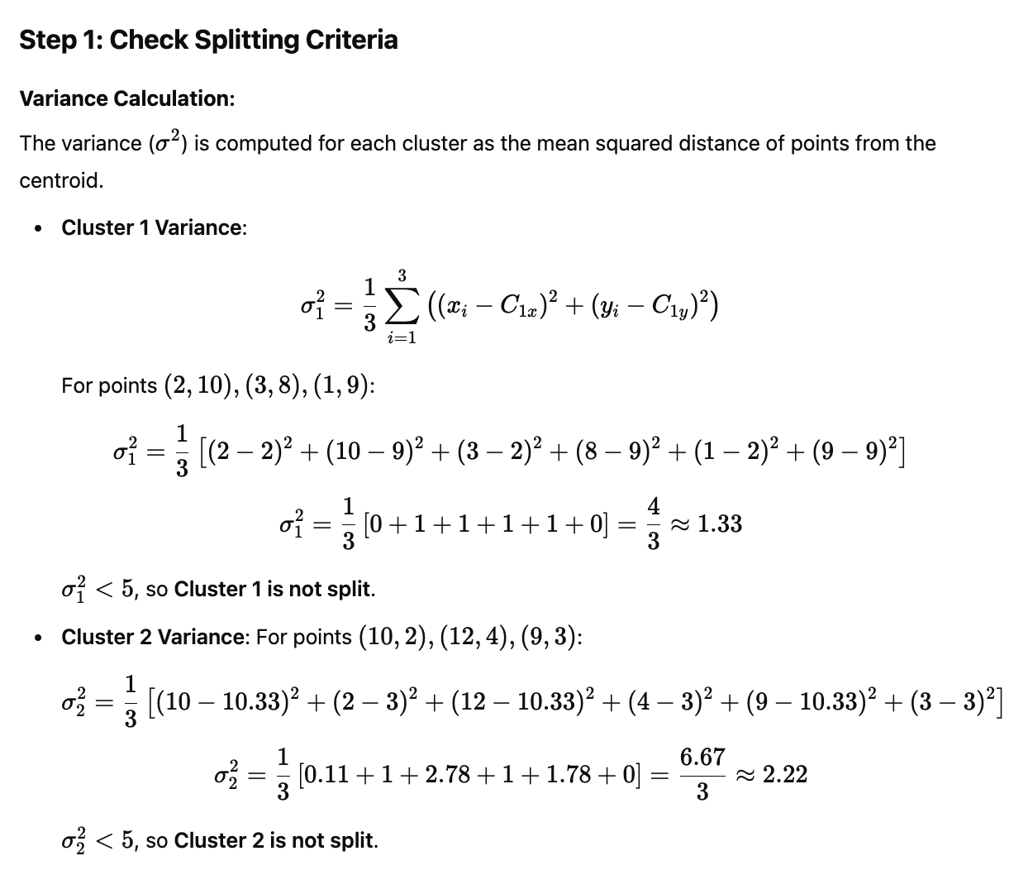
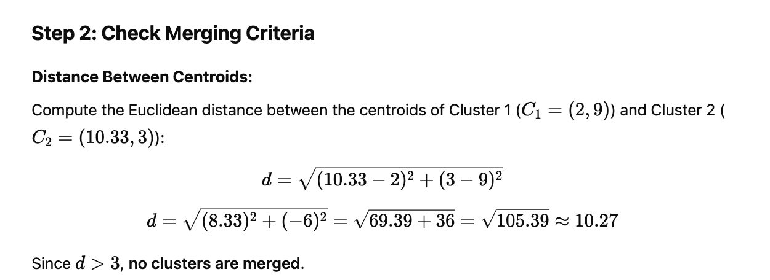

Comparison of K-means and ISODATA in Image Processing
Feature | K-means Clustering | ISODATA Clustering
Cluster Number | Fixed, must be predefined before starting. | Dynamic, adjusts the number of clusters during the process.
Splitting and Merging | No splitting or merging of clusters. | Can split clusters with high variance and merge clusters with low centroid distance.
Flexibility | Less flexible, requires predefined clusters. | More flexible, adapts to the data and can find the optimal number of clusters.
Convergence | Converges when centroids do not change. | Converges after splitting and merging steps are completed.
Computation | Faster, simpler, and more efficient in large datasets. | More computationally expensive due to dynamic adjustments.
Usage in Image Segmentation | Suitable when the number of segments is known. | Suitable when the number of segments is unknown or varies.
Application Example | Segmenting an image into a fixed number of regions (e.g., 3 regions: sky, trees, road). | Segmenting an image with an unknown number of regions based on color variance.

6.3 Region-Based Segmentation Techniques

Types of Region-Based Segmentation Techniques
- Region Growing:
  - Start Point: A seed point (starting pixel) is selected.
  - Thresholding: Neighboring pixels are checked for similarity and added if they meet the similarity threshold.
  - Example: If the initial seed is a pixel with intensity 2 and the threshold is 2, neighboring pixels with intensities between (2-2)0 and (2+2)4 will be added to the region.
  - Repeat the same process for boundary pixels,ex. 1(above 2). for 1,neighboring pixels with intensities between (1-2)-1 and (1+2)3 will be added to the region.

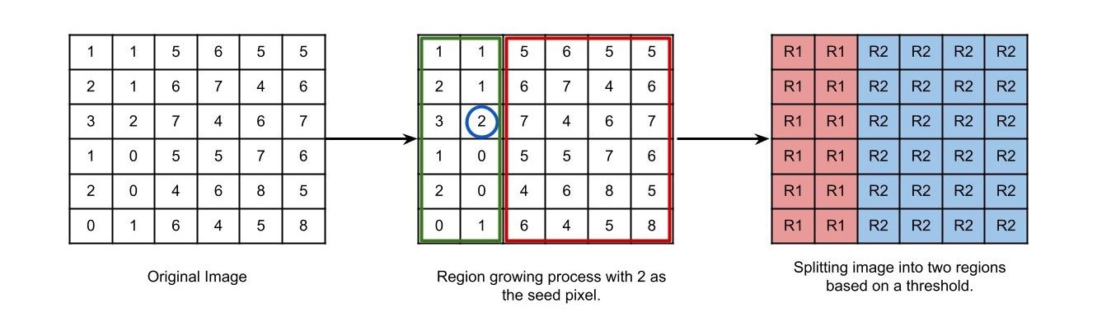
- Region Splitting and Merging:(in detail 6.3.1)
  - Splitting: The image is recursively divided into smaller regions until homogeneous regions are found.
  - Merging: Regions that are too similar to be distinct are merged together.
  - Example: If the image is first split into four quadrants and one of them contains very similar pixels, it will be merged with an adjacent region.
- Watershed Algorithm:(in detail 6.3.2)
  - The watershed algorithm is often used for images with overlapping or touching objects. It simulates the process of flooding regions and identifies boundaries between distinct objects.
  - Example: It can be used to segment touching objects in a microscopic image.

6.3.1. Region Splitting and Merging (RSM)

Region Splitting and Merging is a two-step approach used for image segmentation. It involves recursively splitting the image into smaller regions based on pixel similarity, and then merging adjacent regions if they are similar enough. This method is based on a divide and conquer strategy.

Steps in Region Splitting and Merging

Region Splitting:

The image is divided into smaller square regions, starting from the entire image.

Recursive procedure: This splitting continues recursively until each region meets a homogeneity (max-min<splitting threshold)criterion. Typically, this criterion involves checking whether all pixels within a region are similar enough (based on intensity, texture, or other characteristics).

Region Merging:

Recursive procedure: After splitting, adjacent regions are examined. If two regions are similar(max-min<merge threshold) enough, they are merged.

Merging is done based on a predefined threshold (such as pixel intensity or color). If regions are not similar enough, they remain split.
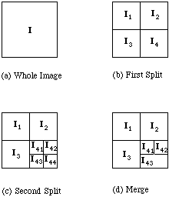
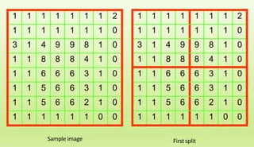
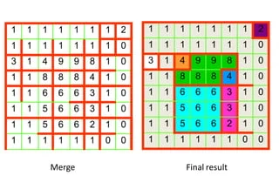

import cv2
import numpy as np

# Load an example image
image = cv2.imread('example_image.jpg', cv2.IMREAD_GRAYSCALE)

# Step 1: Split the image (this will be simplified for the example)
def split_and_merge(image, threshold):
h, w = image.shape
regions = []

# Define a simple splitting function
def split(image, threshold):
if np.max(image) - np.min(image) < threshold: # If homogeneous, no split
return [image]
else:
mid_h, mid_w = h // 2, w // 2
regions = []
regions += split(image[:mid_h, :mid_w], threshold) # Top-left
regions += split(image[:mid_h, mid_w:], threshold) # Top-right
regions += split(image[mid_h:, :mid_w], threshold) # Bottom-left
regions += split(image[mid_h:, mid_w:], threshold) # Bottom-right
return regions

regions = split(image, threshold)
return regions
# Step 2: Apply the splitting and merging
threshold = 50
regions = split_and_merge(image, threshold)

# Step 3: Display the resulting regions
for i, region in enumerate(regions):
print(f"Region {i + 1}:")
cv2.imshow(f"Region {i + 1}", region)

cv2.waitKey(0)
cv2.destroyAllWindows()

6.3.2 Watershed Algorithm

The Watershed Algorithm is used for image segmentation and is based on the concept of treating image pixels as topographic surfaces. The algorithm "floods" the image, starting from markers (known points), and then identifies boundaries where the floodwaters meet. This is typically used to separate objects in an image.

Let's walk through the Watershed algorithm with an example.

Steps of the Watershed Algorithm:

Preprocess the Image (Gradient Calculation or Edge Detection):

This step involves finding the boundaries or gradients in the image to identify where the watershed lines (boundaries between objects) should be.

Marker Initialization:

Mark the "background" and "foreground" pixels. Foreground markers correspond to the objects we want to segment.

Flooding:

The image is flooded, and pixels are assigned to different regions. The regions grow until they meet at watershed boundaries.

Boundary Detection:

The watershed lines are detected where the different regions meet.
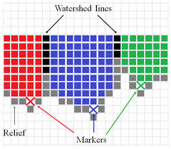
import cv2
import numpy as np
image = cv2.imread('example_image.jpg')
gray = cv2.cvtColor(image, cv2.COLOR_BGR2GRAY)

# Step 1: Apply Canny Edge Detection
edges = cv2.Canny(gray, 50, 150) # Adjust thresholds (50 and 150) as needed

# Step 2: Threshold the edges to create a binary image
_, binary = cv2.threshold(edges, 30, 255, cv2.THRESH_BINARY)

# Step 3: Find markers (initial regions based on binary edges)
markers = np.zeros_like(gray)
markers[binary == 255] = 1 # Mark edge regions as 1

# Step 4: Perform Watershed
cv2.watershed(image, markers)

# Step 5: Mark boundaries with a distinct color
image[markers == -1] = [0, 0, 255] # Mark watershed boundaries in red

# Display the result
cv2.imshow('Watershed Segmentation with Canny', image)
cv2.waitKey(0)
cv2.destroyAllWindows()

